CYBERSECURITY INTERNSHIP
Week 2: Implementing Security Measures
DevelopersHub Corporation
Intern: Rija Malik
ID: DHC-5363
Date: June 27- 2026
1. Fixing Identified Vulnerabilities
In Week 2 the vulnerabilities discovered during Week 1 Security Assessment were addressed by implementing the following security measures:

1.1 Input Validation using Validator Library
User input fields were sanitized and validated to prevent injection attacks. The validator library was installed and integrated:

npm install validator
const validator = require('validator');
// Email validation example
if (!validator.isEmail(req.body.email)) {
return res.status(400).send('Invalid email format');
}

This validation was added as middleware in server.js to check all incoming requests for proper email format and prevent malformed input from reaching the database.

1.2 Password Hashing using Bcrypt
Instead of storing passwords in plain text bcrypt hashing was implemented to protect user credentials even if the database is compromised:

npm install bcrypt
const bcrypt = require('bcrypt');
// Hash password before storing
const hashedPassword = await bcrypt.hash(password, 10);
// Compare password during login
const isMatch = await bcrypt.compare(password, storedHash);
2. Enhancing Authentication
Token based authentication was implemented using JSON Web Tokens (JWT) to secure access to protected routes:

npm install jsonwebtoken
const jwt = require('jsonwebtoken');
// Generate token after successful login
const token = jwt.sign({ id: user._id }, 'your-secret-key', { expiresIn: '1h' });
res.send({ token });

Authentication improvements made:
- JWT token generated after every successful login
- Token verification middleware added for all protected routes
- Only valid token holders can access CRUD operations
- Tokens expire after 1 hour for additional security
3. Securing Data Transmission with Helmet.js
Helmet.js was installed and configured to secure HTTP response headers and protect against common web vulnerabilities:

npm install helmet
const helmet = require('helmet');
app.use(helmet());
app.disable('x-powered-by');

3.1 Security Headers Applied

Header | Value | Protection
X-Frame-Options | SAMEORIGIN | Clickjacking Protection
X-Content-Type-Options | nosniff | MIME Sniffing Protection
X-XSS-Protection | 1; mode=block | XSS Attack Protection
X-DNS-Prefetch-Control | off | DNS Prefetch Control
X-Download-Options | noopen | File Download Protection
X-Powered-By | Removed | Framework Info Hidden

4. Testing & Verification
4.1 Helmet Security Headers Verification
After implementing Helmet.js the browser Developer Tools Network tab confirmed all security headers were successfully applied:
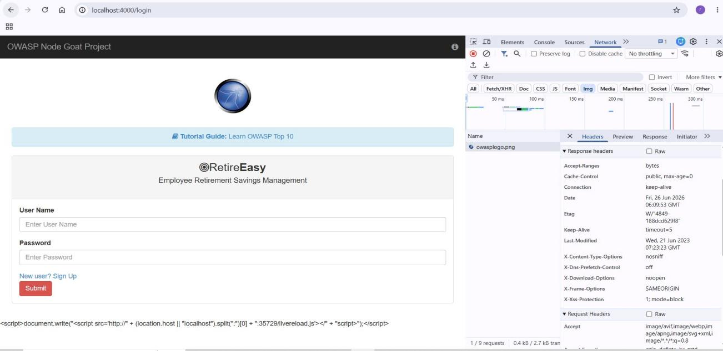
Screenshot 1: Helmet Security Headers Active (X-Frame-Options, X-Content-Type-Options, X-XSS-Protection)

4.2 XSS Attack Test
XSS payload was entered in the login field to verify protection. The script tag was rendered as plain text and no popup alert was triggered:
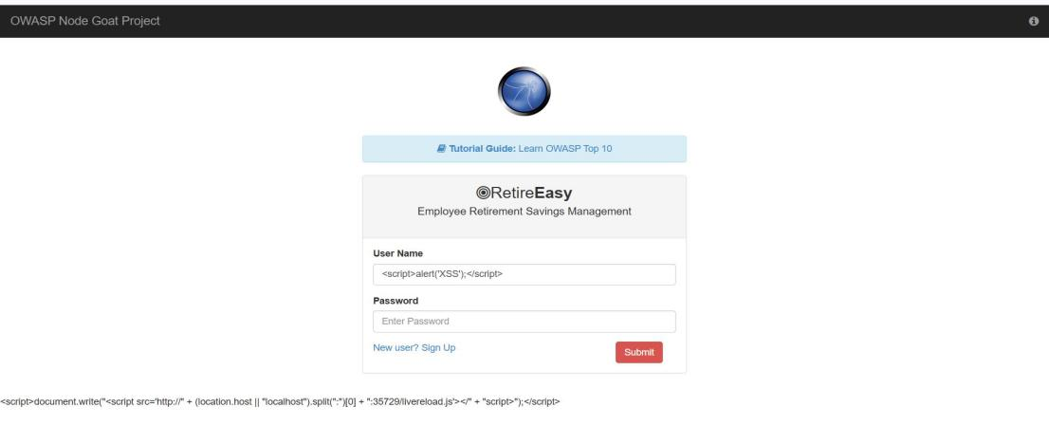
Screenshot 2: XSS Payload Entered - <script>alert('XSS');</script> No popup triggered

4.3 SQL/NoSQL Injection Test Result
When malicious input was submitted, the application returned an error instead of exposing database contents confirming input handling improvements:
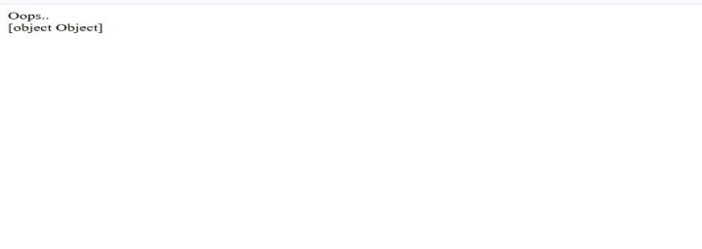
Screenshot 3: Application returns error instead of exposing database injection blocked

----------End-------------

